Student Name : Feng Qingyu

Group : TS1

Date : 08/04/2021

LAB 4: ANALZING NETWORK DATA LOG

You are provided with the data file, in .csv format, in the working directory. Write the program to extract the following informations.

Exercise 4A: TOp TALKERS and LISTENERS

One of the most commonly used function in analyzing data log is finding out the IP address of the hosts that send out large amount of packet and hosts that receive large number of packets, usually know as TOP TALKERS and LISTENERS. Based on the IP address we can obtained the organization who owns the IP address.

List the TOP 5 TALKERS

Rank | IP address | # of packets | Organisation
1 | 193.62.192.8 | 3041 | European Bioinformatics Institute
2 | 155.69.160.32 | 2975 | Nanyang Technological University
3 | 130.14.250.11 | 2604 | National Library of Medicine
4 | 14.139.196.58 | 2452 | Indian Institute of Technology (IIT), Guwahati
5 | 140.112.8.139 | 2056 | Taiwan Academic Network

TOP 5 LISTENERS

Rank | IP address | # of packets | Organisation
1 | 103.37.198.100 | 3841 | Agency for Science, Technology and Research i.e. A*STAR
2 | 137.132.228.15 | 3715 | National University of Singapore
3 | 202.21.159.244 | 2446 | Republic Polytechnic, Singapore
4 | 192.101.107.153 | 2368 | Pacific Northwest National Laboratory
5 | 103.21.126.2 | 2056 | Indian Institute of Technology Bombay

Exercise 4B: TRANSPORT PROTOCOL

Using the IP protocol type attribute, determine the percentage of TCP and UDP protocol

 | Header value | Transport layer protocol | # of packets
1 | 6 | TCP | 56064(80.82%)
2 | 17 | UDP | 9462(13.64%)
3 | 50 | ESP | 1698(2.45%)

Exercise 4C: ApplicationS PROTOCOL

Using the Destination IP port number determine the most frequently used application protocol.
(For finding the service given the port number https://www.adminsub.net/tcp-udp-port-finder/ )

Rank | Destination IP port number | # of packets | Service
1 | 443 | 13423 | https; threat; trojan
2 | 80 | 2647 | http; www-http; threat; trojan
3 | 52866 | 2068 | Dynamic and/or Private Ports; Xsan. Xsan Filesystem Access
4 | 45512 | 1356 | Unassigned
5 | 56152 | 1341 | Dynamic and/or Private Ports; Xsan. Xsan Filesystem Access

Exercise 4D: Traffic

The traffic intensity is an important parameter that a network engineer needs to monitor closely to determine if there is congestion. You would use the IP packet size to calculate the estimated total traffic over the monitored period of 15 seconds. (Assume the sampling rate is 1 in 1000)
Total Traffic( MB) | 61776.95
Total traffic is the total size of ip size within the 15 seconds, so I sum up all the ip size in the given dataset. Because the sampling rate is 1 in 1000, so I multiply by 1000. The unit of the IP size is Byte, so I convert it from byte to MB by dividing 1024 twice.

Exercise 4E: ADDITIONAL ANALYSIS

Please append ONE page to provide additional analysis of the data and the insight it provides.
Examples include:
Top 5 communication pairs;
Visualization of communications between different IP hosts;
etc.
Please limit your results within one page (and any additional results that fall beyond one page
limit will not be assessed).
Top 5 communication pairs
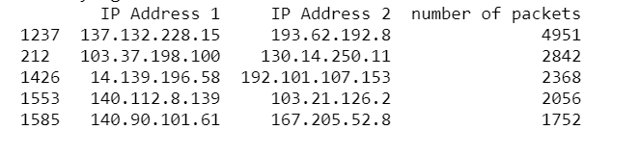
Communication pairs means if IP address A sends packets to address B or IP address B sends packets to address A, they both contribute to communication pairs A-B. Therefore, I group all the IP addresses with same IP address1 and IP address 2 pair and count the number.
Visualization of communications between different IP hosts
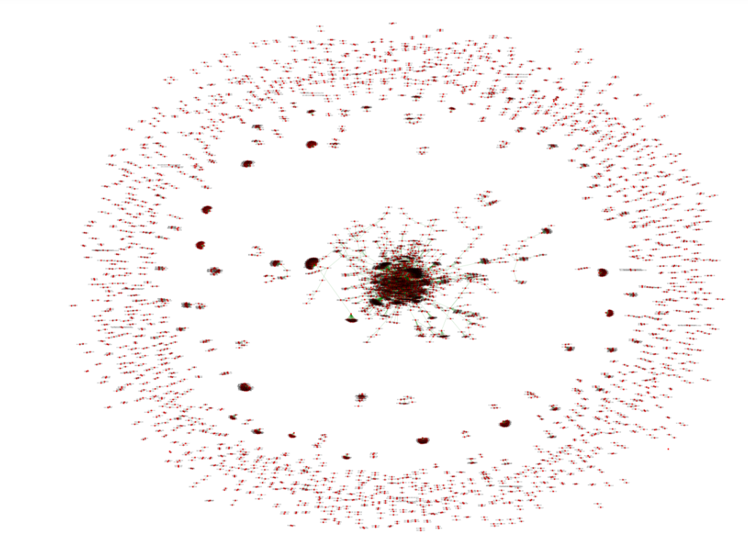
For each source IP and destination IP, there will be an edge between them. The nodes(source IP and destination IP) and the link can represent the communication of the two hosts.
By observing the figure above, we can know how many communications between any two IP addresses. On the figure, the denser the links are, the more communications happen between any two nodes inside that area.

Exercise 4F: SOFTWARE CODE

Please attach a copy of your code in an appendix.
